Jamaica Farewell- Harry Belafonte
1956- BPM 144- B-BH-HBH pour chaque accord
Intro : A D E7 A

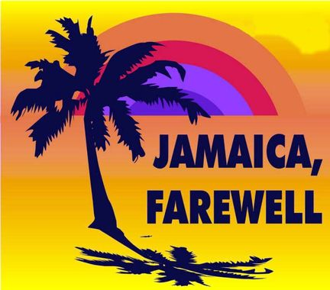
Couplet 1
A D
Down away where the nights are gay
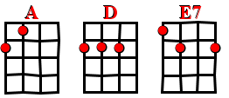
E7 A
And the sun shines daily on the mountain top
A D
I took a trip on a sailing ship
E7 A
And when I reached Jamaica I made a stop

Refrain
A D
But I'm sad to say I'm on my way.
E7 A
Won't be back for many a day.
A D
My heart is down my head is turning around.
E7 A
I had to leave a little girl in Kingston town.

A D E7 A

A D
Sounds of laughter everywhere.
E7 A
And the dancing girls swing to and fro.
A D
I must declare my heart is there,
E7 A
though I've been from Maine to Mexico

Refrain

A D
Down at the market you can hear,
E7 A
ladies cry out while on their heads they bear
A D
Akey rice and fish are nice
E7 A
and the rum is fine anytime o’ year

Refrain

Couplet 1

Refrain X2 enchaînés – 1er SANS A D E7 A- 2ème Sad to say… et A D E7 A
V3

