John Lennon – Imagine

INTRO
Riff 2x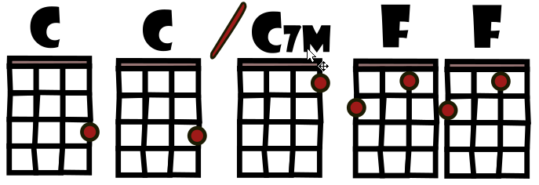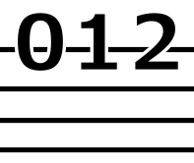

Couplet 1
C Cmaj7 F
Imagine there's no heaven
C Cmaj7 F
It's easy if you try
C Cmaj7 F
No hell below us
C Cmaj7 F
Above us only sky

Refrain 1
F Am Dm Dm7
Imagine all the people
G G G7
Living for to - day a-hah

Couplet 2
C Cmaj7 F
Imagine there's no countries
C Cmaj7 F
It isn't hard to do
C Cmaj7 F
Nothing to kill or die for
C Cmaj7 F
And no religion too

Refrain 2
F Am Dm Dm7
Imagine all the people
G G G7
Living life in peace hou-hou-ou

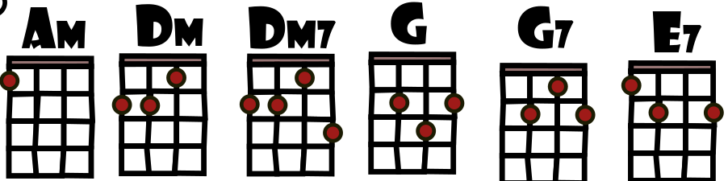

Pont 1
F G C E7
You may say I'm a dreamer
F G C E7
But I'm not the only one
F G C E7
I hope some day you'll join us
F G C
And the world will be as one

Couplet3
C Cmaj7 F
Imagine no pos - sessions
C Cmaj7 F
I wonder if you can
C Cmaj7
No need for greed or hunger
C Cmaj7 F
A brotherhood of man

Refrain 3
F Am Dm Dm7
Imagine all the people
G G G7
Sharing all the world -hou-hou-ou

Pont 2
F G C E7
You may say I'm a dreamer
F G C E7
But I'm not the only one
F G C E7
I hope some day you'll join us
F G C
And the world will live as one

