Just like heaven (en Duo)  - The Cure (1987) 4/4 150 à la noire | 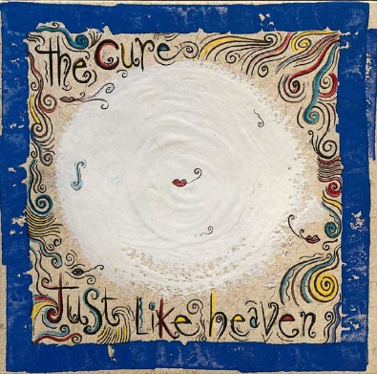
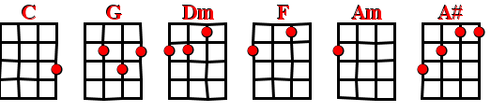

Couplet | C | G | Dm | F

Refrain | Am | Bb | X 3 |  | Refrain  final | Am | Bb | X 2
 | F | (3x) | G |  |  | Am | Bb | F

C G
"Show me how you do that trick
Dm F
The one that makes me scream" she said
C G
"The one that makes me laugh" she said
Dm F
And threw her arms around my neck
C G
"Show me how you do it
Dm F
And I promise you I promise that
C G
I'll run away with you
Dm F
I'll run away with you"

Interlude –x4-: C G Dm F

C G
Spinning on that dizzy edge
Dm F
I kissed her face and kissed her head
C G
And dreamed of all the different way
Dm F
I had to make her glow
C G Dm
"Why are you so far away?" she said
F C G
"Why won't you ever know that I'm in love with you
Dm F
That I'm in love with you"

Am Bb
You…. Soft and only
Am Bb
You…. Lost and lonely
Am Bb
You..… Strange as angels
F F
Dancing in the deepest oceans
F G
Twisting in the water
(C)
You're just like a dream

Interlude - C G Dm F x4

C G
Daylight licked me into shape
Dm F
I must have been asleep for days
C G
And moving lips to breathe her name
Dm F
I opened up my eyes
C G
And found myself alone alone
Dm F
Alone above a raging sea
C G
That stole the only girl I loved
Dm F
And drowned her deep inside of me

Am Bb
You…. Soft and only
Am Bb
You….Lost and lonely
Am Bb F
You…Just like heaven
V2

