Just like Heaven – The Cure 1987

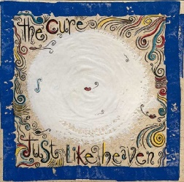**4 temps, 150 à la noire, strum sur 8 temps : B.B.BH.H.H.H.HBH (1 strum sur 2 accords)**

|  |  |  |  |  |
| --- | --- | --- | --- | --- |
| **Intro - couplet** | **C** | **G** | **Dm** | **F** |

|  |  |  |  |  |  |  |  |  |
| --- | --- | --- | --- | --- | --- | --- | --- | --- |
| **Refrain** | **Am** | **Bb** | **X 3** |  | **Refrain**  **final** | **Am** | **Bb** | **X 3** |
| **F** | **(3x)** | **G** |  | **F…** |  |  |

refrain

***Intro –-: C G Dm F 8x avec solo***

**C G**

**"Show me how you do that trick**

**Dm F**

**The one that makes me scream" she said**

**C G**

**"The one that makes me laugh" she said**

**Dm F**

**And threw her arms around my neck**

**C G**

**"Show me how you do it**

**Dm F**

**And I promise you I promise that**

**C G**

**I'll run away with you**

**Dm F**

**I'll run away with you"**

**Interlude –x4-: C G Dm F**

**C G**

**Spinning on that dizzy edge**

**Dm F**

**I kissed her face and kissed her head**

**C G**

**And dreamed of all the different ways**

**Dm F**

**I had to make her glow**

**C G**

**"Why are you so far away?" she said**

**Dm F**

**"Why won't you ever know that I'm**

**C G**

**in love with you**

**Dm F**

**That I'm in love with you"**

Version duo : **Elle Lui**

V3

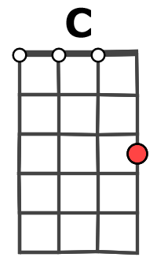

**Am… Bb…**

**You…. Soft and only**

**Am… Bb…**

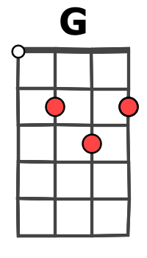

**You…. Lost and lonely**

**Am… Bb…**

**You..… Strange as angels**

**F F**

**Dancing in the deepest oceans**

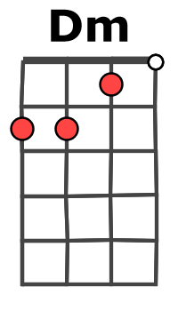

**F G**

**Twisting in the water**

**(C)**

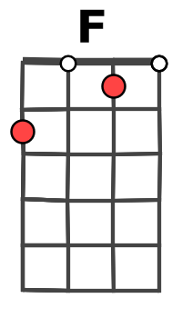

**You're just like a dream**

**Interlude - C G Dm F x4**

**C G**

**Daylight licked me into shape**

**Dm F**

**I must have been asleep for days**

**C G**

**And moving lips to breathe her name**

**Dm F**

**I opened up my eyes**

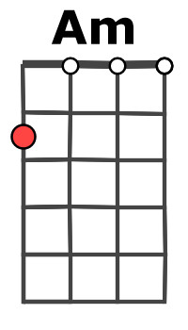

**C G**

**And found myself alone alone**

**Dm F**

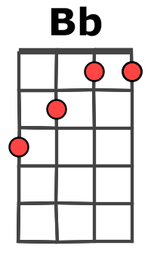

**Alone above a raging sea**

**C G**

**That stole the only girl I loved**

**Dm F**

**And drowned her deep inside of me**

refrain

**Am Bb**

**You…. Soft and only**

**Am Bb**

**You….Lost and lonely**

**Am Bb F**

**You…Just like heaven**