LOVE IS ALL, R. GLOVER (and guest the Butterfly ball), 1974  Song : G  Intro : B X 4 sur chaque accord B E A D |  | 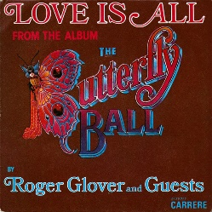
C /G C / F  Everybody's got to live together  C / G C / F  All the people got to understand  C / G C / F  So love your neighbour like you love your brother  G  Come on and join the band  C / G C / F  Well all you need is love and understanding  C / G C / F  Ring the bell and let the people know  C / G C / F  We're so happy and we're celebrating  G  Come on and let your feelings show  Am D  Love is all, Well love is all  G C  Love is all, can't you hear the call  Am D  So love is all you need/, love is all  G C  You need at the butterfly ball  Break (4 « B » par accord)  B E A D  C / G C / F  Ain't you happy that we're all together  C / G C / F  At the ball in nature's countryside  C / G C / F  And although we're wearing different faces  G  Nobody wants to hide  Am D  Love is all and all is love and  G C  It's easy, yes it's so easy  Am D  At the Butterfly Ball where love is all  G C  And it's so easy  Break valse B E A D X4 | C / G C / F  All you need is love and understanding  C / G C / F  Hey, ring the bell and let the people know  C / G C / F  We're so happy and we're celebratin'  G  Let your feelings show  Am D G C  Love is all, yes love is all at the Butterfly BaAall  Am  Love is big, love is small  D  Love is free, love is all  G C  At the Butterfly Ball  Am D  When you back's to the wall  G  When you're starting to fall  C  You got something to lean on  Am D  Love is everything  G C  It can make you sing/ at the Butterfly Ball  Am D G C  Love is all, I say love is all, yes love is all At the Butterfly Ball  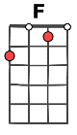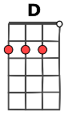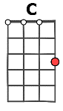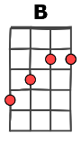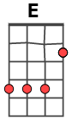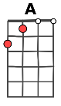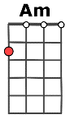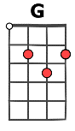  Et les barrés (I) pour le break et la « valse »  