You’re the one that I want
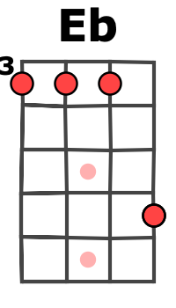
(Grease, 1978) 214 BPM en Bb, tonalité originale en C
1 & 2 & 3 & 4 & x 2
b B h b h x 2

Bb // Bb7 / Eb
Ooh, Ooh, Ooh, honey
1 & 2 & 3 & 4 & 1 & 2 & 3 & 4 &
B B B B h b h

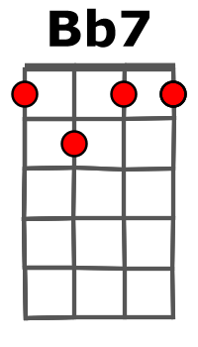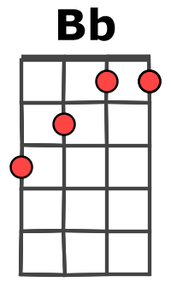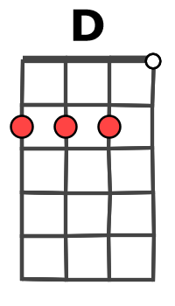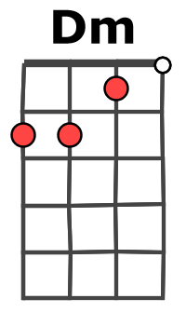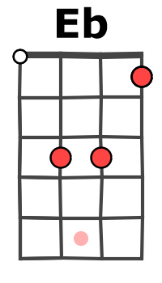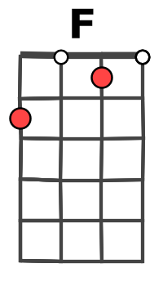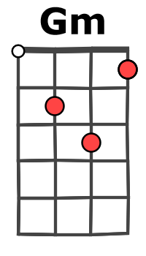

Gm Gm Gm Gm Eb Bb
I got chills,……… they're multiply-in’,……. and I'm lo…..sing control
D Gm Gm Gm
'Cause the power……. you're supplyin’, it's electrifyin’ !

Bb Dm Gm Eb
You better shape up…”Ooh”... cause I need a man…”Ooh”… “and my heart is set on you”
Bb Dm Gm Eb
You better shape up…”Ooh”… you better un-derstand…”Ooh”… to my heart I must be true
Eb Eb
Nothin' left, nothin' left for me to do
REFRAIN

Bb Bb // Bb7 / Eb
You're the one that I want (you are the one I want) Ooh, Ooh, Ooh, honey
Bb Bb // Bb7 / Eb
The one that I want (you are the one I want) Ooh, Ooh, Ooh, honey
Bb Bb // Bb7 / Eb
You're the one that I want (you are the one I want) Ooh, Ooh, Ooh
F F
The one I need (the one I need) Oh, yes indeed (yes, indeed)

Gm Gm Gm Gm Eb Bb
If you're filled………. with affect-tion… you're too shy……. to convey
D Gm Gm Gm
Meditate in…… my direction Feel your way
Bb Dm Gm Eb
I better shape up…”Ooh”... cause you need a man, I need a man who can keep me satisfied
Bb Dm Gm Eb
I better shape up…”Ooh”`... If I'm gon-na prove, you better prove that my faith is justified
Eb Eb
Are you sure ? Yes, I'm sure down deep inside

REFRAIN X 3 M-A – en GV1

