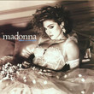
LIKE A VIRGIN
F F x 2
E|-1------1--1----------
C|---2--0-------2—0—2---

INTRO : Madonna, 1984 120 BPM - ½ ton

F F F F
I made it through the wilderness somehow I made it through
Gm7 Gm7 F F
F F
1 & 2 & 3 & 4 & 1 & 2 & 3 & 4 &
x h x x i x x x i x x h x x x x
Didn't know how lost I was until I found you
F F F F
I was beat incomplete I'd been had I was sad and blue
Gm7 Dm7* Gm7 Dm7*
Gm7 Dm7* (* : anticipé)
1 & 2 & 3 & 4 & 1 & 2 & 3 & 4 &
i i h h i h h i h i h ih
But you made me feel yeah you made me feel
Csus4 iii // C i Csus4 ii / C i (i)
Shiny and new
1 & 2 & 3 & 4 & 1 & 2 & 3 & 4 &
x h x x i x x x i x x h x x x x
F F F F
Like a virgin, hey touched for the very first time
Gm7 Gm7 F F
REFRAIN
Like a vir---gin when (with) your heart beats (beat) next to mine

F F F F
Gonna give you all my love boy my fear is fading fast
Gm7 Gm7 F F
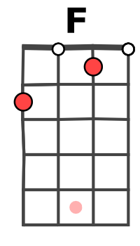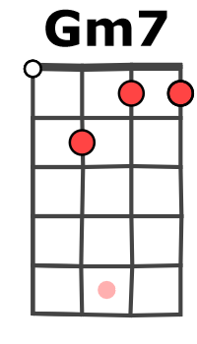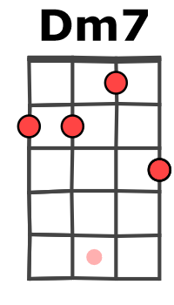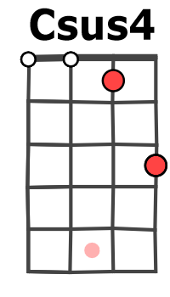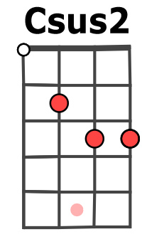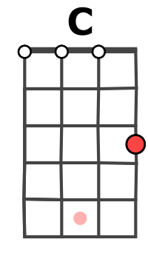

Been saving it all for you 'cause only love can last

F F F F
You're so fine and you're mine make me strong yeah you make me bold
Gm7 Dm7* Gm7 Dm7*
Oh your love thawed out yeah your love thawed out
Csus4 iii .// C i Csus4 ii / C i (i)
What was scared and cold

REFRAIN Dm7 G Dm7 G Dm7 G Dm7 G
Oooh, oooh, oooh
F F F F
You're so fine and you're mine I'll be yours 'till the end of time
Gm7 Dm7* Gm7 Dm7*
Cause you made me feel yeah you made me feel
Csus4 i i i // C i Csus4 i i / C i (i) REFRAIN
I've nothing to hide

F F F F
Like a virgin, ooh, ooh, like a virgin, feels so good inside
Gm7 Gm7 F F
When you hold me and your heart beats and you love me

F F Gm7 F F F Gm7 Fi
Oh-oh, oh oh Ooh baby, yeah, can’t you hear my heart beat for the very first time ?

Merci à Ukulélé Cheats https://www.youtube.com/watch?v=cBRApKtpG5o

