In the navy (Village People, 1979) 126 BPM
1 2 3 4
B B B B

=
x 2
1 & 2 & 3 & 4 & 5 & 6 & 7 & 8 & 1 & 2 & 3 & 4 & 5 & 6 & 7 & 8 &
X X X X X X X X X X X X X X

Gm Gm Gm Bb
Where can you find pleasure, search the world for treasure, learn science technology ?
Cm Bb Cm7 D7
Where can you begin to make your dreams all come true on the land or on the sea ?
Gm Gm Gm Bb
Where can you learn to fly, play in sports and skin dive, study oceanography ?
Cm Bb Cm7 D7
Sign off for the big band or sit in the grandstand when your team and others meet

Gmaj7 Gmaj7 Am7 D7
In the navy, yes, you can sail the seven seas… In the navy, yes, you can put your mind at ease
Am7 D7 Gmaj7 D / D7
In the navy, come on now people, make a stand… In the navy, can't you see we need a hand
Gmaj7 Gmaj7 Am7 D7
In the navy, come on protect the motherland In the navy, come on and join your fellow man
Am7 D7 Gmaj7 D / D7
In the navy, come on people and make a stand… In the navy,in the navy, in the navy, oh

x 2 They want you ! They want you ! They want you as a new recruit ! x 2

Gm Gm Gm Bb
If you like adventure, don't you wait to enter the recruiting office fast
Cm Bb Cm7 D7
Don't you hesitate, there is no need to wait they're signing up new seamen fast
Gm Gm Gm Bb
Maybe you are too young to join up today but don't you worry 'bout a thing
Cm Bb Cm7 D7
For I'm sure there will be al-ways a good na-vy to protect the land and sea

REFRAIN

x 2 They want you ! They want you ! They want you as a new recruit ! x 2
(2ème fois : Who me ?)
Gm7 Gm7 Gm7 Gm7
But, but, but, I'm afraid of water
Hey, hey look man I get seasick even watchin' it on TV
They want you ! Oh my goodness They want you ! What am I gonna do in a submarine?
They want you ! They want you ! (in the navy)
Gm7 Gm REFRAIN
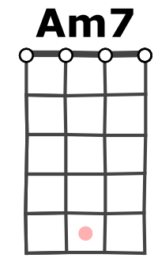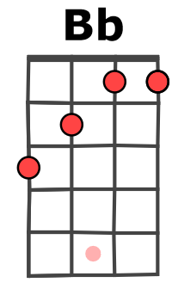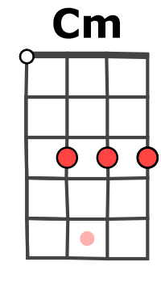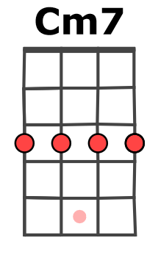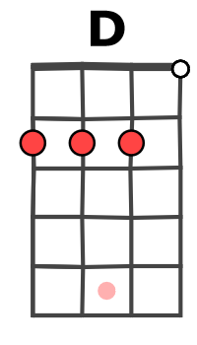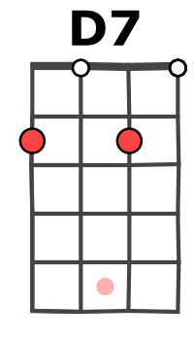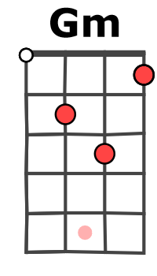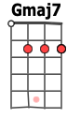
M-A / V1

