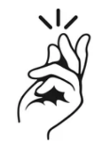
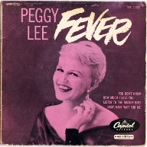
FEVER – Peggy Lee – 1959 - 136 bpm
Intro Am Am E7 Am x 2
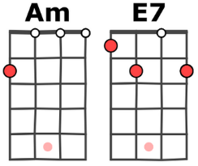
Never know how much I love you, never know how much I care
When you put your arms around me, I get a fever that's so hard to bear
You give me fever
when you kiss me, fever when you hold me tight
Fever - in the the morning, fever all through the night.
Sun lights up the daytime, moon lights up the night
I light up when you call my name, and you know I'm gonna treat you right
You give me fever
when you kiss me, fever when you hold me tight
Fever - in the the morning, fever all through the night.
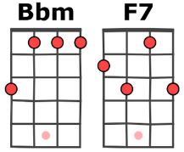
Everybody's got the fever, that is something you all know
Fever isn't such a new thing, fever started long ago.
+1/2 ton : Bbm F7 / Bbm7
Romeo loved Juliet, Juliet she felt the same
When he put his arms around her, he said "Julie baby you're my flame"
Thou givest fever
when we kisseth, fever with thy flaming youth
Fever - I'm afire, fever yea I burn forsooth.
+1/2 ton : Bm F#7 / Bm7
Captain Smith and Pocahontas had a very mad affair
When her Daddy tried to kill him, she said "Daddy-O don't you dare"
Give me fever
with his kisses, fever when he holds me tight
Fever - I'm his Missus, Oh daddy won't you treat him right.
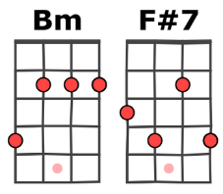
Now you've listened to my story, here's the point I have made:
Chicks were born to give you fever, be it Fahrenheit or Centigrade
They give you fever
when you kiss them, fever if you live and learn
Fever - till you sizzle, what a lovely way to burn.
What a lovely way to burn.
What a lovely way to burn.

