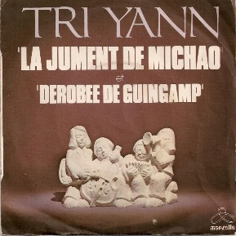

**La Jument de Michao**

Tempo : 105 à la noire, 4 temps (binaire)

**Couplets**

|  |  |  |  |
| --- | --- | --- | --- |
| **Dm** | **Dm/C** | **Dm** | **Dm/C** |



**V2**

**Refrains**

|  |  |  |  |
| --- | --- | --- | --- |
| **Dm** | **C** | **C** | **Dm** |
| **Dm** | **C** | **C** | **Dm** |

