|  |  |
| --- | --- |
| HEROES – *David Bowie (1977)* |  |

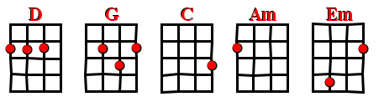



BPM : 113 (4/4) STRUM :

[Intro] D G D G

D G

**I** - I wish you could swi**m**

D G

Like the **do**lphins - like dolphins can swi**m**

C D

Though n**o**thing - nothing will keep us tog**e**ther

Am / Em D

We can **be**at them forever and **e**ver

C / G D

Oh we can be H**e**roes just for one da**y**

[Interlude] **x2**  D G D G

D G

**I** - I will be K**i**ng

D G

And y**ou** - you will be Q**ue**en

C D

For **no**thing will drive them a**wa**y

Am / Em D

We can **be**at them forever and **e**ver

C / G D

Oh we can be H**e**roes just for one da**y**

 D G

V4

**I** - I can re**mem**ber

*- I remember -*

D G

**St**anding by the w**a**ll

- *By the wall* -

D G

And the **gua**rds shot above **our** heads

– *Over our heads -*

D G

And we k**i**ssed as though nothing would f**al**l

- *Nothing could fall -*

C D

And the **sh**ame was on the other **si**de

Am / Em D

Oh we can **be**at them forever and **e**ver

C / G D

Then we can be H**e**roes just for one da**y**

[Interlude] D G D G

D G D

We can be **He**roes

G D

We can be **He**roes

G D

We can be **He**roes just for one d**ay**

G

We can be **He**roes