I TRY – Macy Gray (1999)
V3

D A Em7 Em7 X 2  G Gbm7 Em7 A  D Asus4 Em7 G / A X 2  FMaj7 Am7 FMaj7  Em7 C7  Bm7 Em Em | 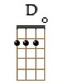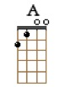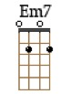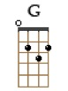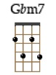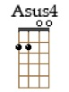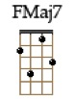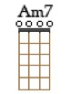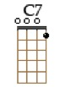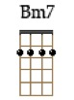  BPM : 70 (4/4) | STRUM :

D A
Games, changes and fears
Em7 Em7
When will they go from here? When will they stop?
D A
I believe that fate has brought us here
Em7 Em7
And we should be together babe, but were not.

[RIFF]
G Gbm7
I play it off but I’m dreaming of you
Em7 ↓ - ↓ - ↓ - ↑ A
And I’ll keep my cool but I’m fiendin’

D
I try to say goodbye and I choke
Asus4
I try to walk away and I stumble
Em7
Though I try to hide it, it’s clear
G ↓ - ↓ - ↓ - ↑ A↓
My world crumbles when you are not near

D
Goodbye and I choke
Asus4
Try to walk away and I stumble
Em7
Though I try to hide it, it’s clear
G ↓ - ↓ - ↓- ↑ A↓
My world crumbles when you are not near

D A
….I may appear to be free
Em7 Em7
But I’m just a prisoner of your love
D A
And I may seem alright and smile when you leave
Em7 Em7
But my smiles are just a front, just a front

[RIFF]
G Gbm7
I play it off but I’m dreaming of you
Em7 ↓ - ↓ - ↓ - ↑ A
And I’ll keep my cool but I’m fiendin’

[CHORUS]

FMaj7 Am7 FMaj7
Here is my confession, May I be your possession
Em7 C7
Boy I need your touch, your love kisses and such
Bm7 Em Em
With all my might I try but this I can’t deny, deny

[RIFF]
G Gbm7
I play it off but I’m dreaming of you
Em7 ↓ - ↓ - ↓ - ↑ A
And I’ll keep my cool but I’m fiendin’

[CHORUS]

