Riptide (Vance Joy, 2013) 202 bpm
1 . 2 . 3 . 4 . x 2
b B h B h x 2
Cordes : 4/3 2/1 2/1 2/1 2/1

INTRO : Am / G C x 2

Am / G C
I was scared of den-tists and the dark
Am / G C
I was scared of pretty girls and starting conversations
Am / G C
Oh, all my friends are turning green
Am / G C
You're the magician's assis-tant in their dreams
PREREFRAIN
Am / G C Am / G C ↓
Ohhhhhhhhhhhhhhhh Ohhhhhhhhhhhhhhhh…… and they come unstuck

Am / G C
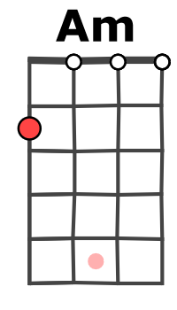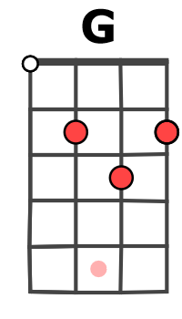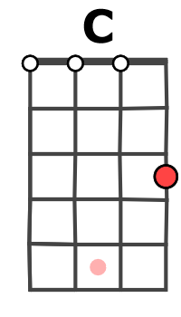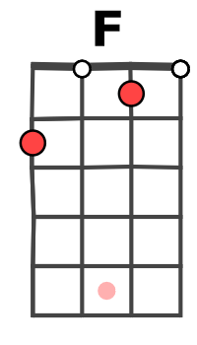

Lady, running down to the riptide, taken away…
Am / G C
to the dark side, I wanna be your left hand man`
REFRAIN
Am / G C
I love you when you're singing that song and I got a lump
Am / G C
in my throat 'cause you're gonna sing the words wrong

Am / G C
Is this movie that I think you'll like ?
Am / G C
This guy decides to quit his job and heads to New York City
Am / G C
This cowboy's running from himself
Am / G C
And she's been living on the highest shelf
E……………..3……0 x 4
C… 2H4…4……0….

PREREFRAIN REFRAIN

Am G C F
I just wanna, I just wanna know… If you're gonna, if you're gonna stay
Am G C F ↓
I just gotta, I just gotta know… I can't have it, I can't have it any other way
PONT
Am ↓ / G ↓ C ↓
I swear she's destined for the screen

Am ↓ / G ↓ C ↓
Closest thing to Michelle Pfeiffer that you've ever seen, oh

REFRAIN x 3 ( doux, moyen, fort )
M-A v4
Am / G C ↓
FIN : I got a lump in my throat 'cause you're gonna sing the words wrong

