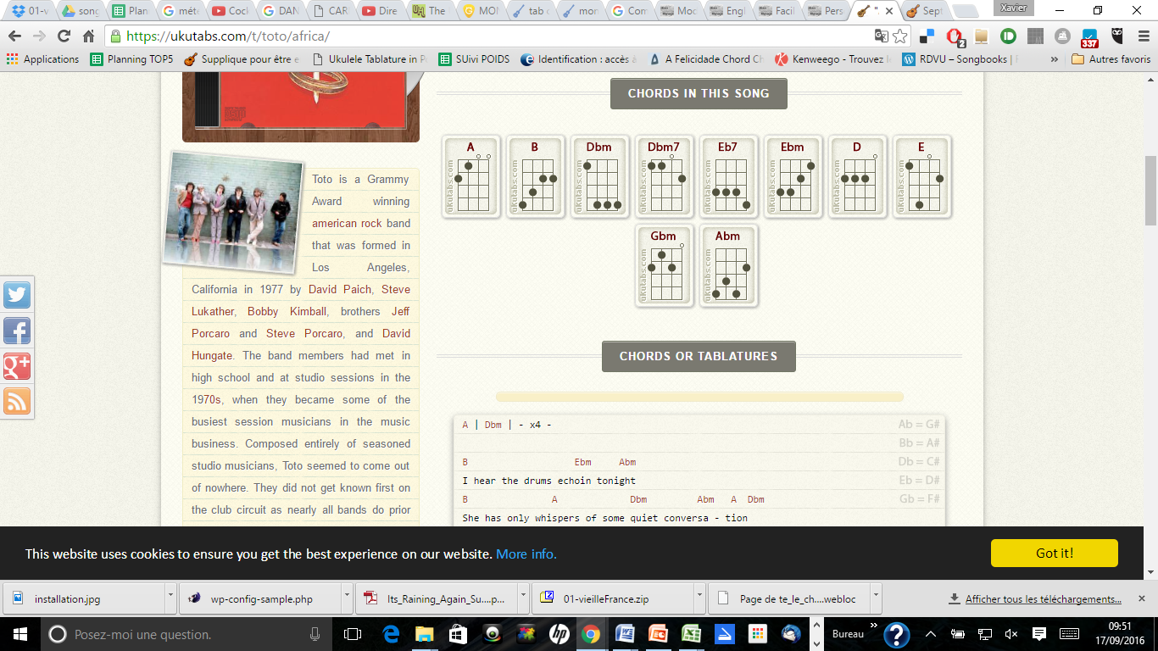
Africa
Toto
1982
A | Dbm | - x4 -

B Ebm Abm
I hear the drums echoin tonight
B A Dbm Abm A Dbm
She has only whispers of some quiet conversa - tion
B Ebm Abm B
She's coming in twelve thirthy flight the moolight winds

A Dbm7 Abm A Dbm
Reflect the stars that guide me toward salva-tion

B Ebm Abm
I stopped an old man along the way
B A Dbm Abm A Dbm
Hoping to find some old forgotten words of ancient melo-dies
B Eb7 Abm A Dbm
He turned to me as if to say hurry boy it's waiting there for you

CHORUS :

Gbm D A E
Gonna take a lot to drag me away from you
Gbm D A E
There's nothing that a hundred men or more could ever do
Gbm D A E
I bless the rains down in Africa
Gbm D A Dbm E Gbm A Dbm
Gonna take some time to do the things we never had

B Ebm Abm
The wild dogs cry out in the night
B A Dbm Abm A Dbm
As they grow restless longing for some solitary compa-ny
B Ebm Abm
I know that I must do what's right
B A Dbm Abm A Dbm
Sure as kilimangiaro rises like olimpus above the seranget-ti

B Eb7 Abm
I seek to cure what's deep inside

Abm A Dbm
Frightened of this thing that I've become

- CHORUS

B Ebm Abm B A Dbm Abm A Dbm

B Eb7 Abm A Dbm
hurry boy it's waiting there for you

- CHORUS

