Sunday Morning - The Velvet underground (1967)

Intro : G C G C

G C G C
Sunday morning, brings the dawn in
G / B7 Em A D
It's just a restless feeling by my side
G C G C
Early dawning, Sunday morning
G / B7 Em A D
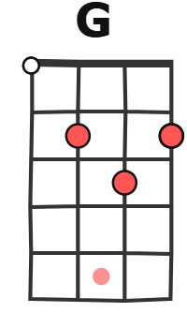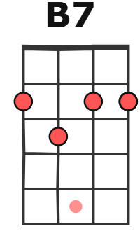
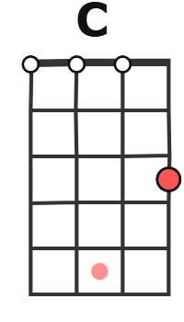
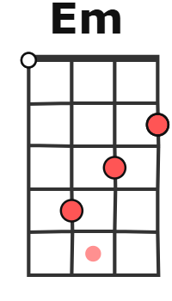
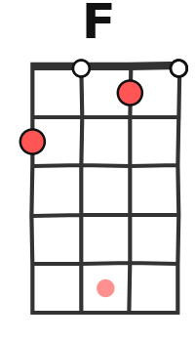
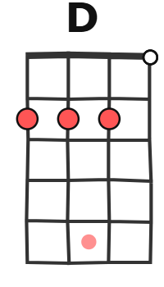
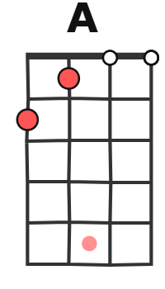
It's just the wasted years so close behind

G C
Watch out, the world's behind you
G C
There's always someone around you
Am F D
who will call, It's nothing at all

G C G C
Sunday morning and I'm falling
G / B7 Em A D
I've got a feeling I don't want to know
G C G C
Early dawning, Sunday morning
G / B7 Em A D
It's all the streets you crossed, not so long ago

Solo : G C G C G / B7 Em A7 D
G C
Watch out, the world's behind you
G C
There's always someone around you
Am F D
who will call, It's nothing at all

G C G C G C
Sunday morning Sunday morning Sunday morning

