Just like Heaven – The Cure 1987
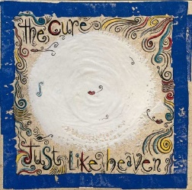
tempo : 150 à la noire, strum sur 4 temps : B.Bh hB – tonalité originale A
Intro - couplet | C | G | Dm | F

Refrain | Am | Bb | X 3 |  | Refrain  final | Am | Bb | X 3
Refrain | F | (3x) | G |  | Refrain  final | F…
refrain

Intro –-: C G Dm F 8x avec solo

C G
"Show me how you do that trick
Dm F
The one that makes me scream" she said
C G
"The one that makes me laugh" she said
Dm F
And threw her arms around my neck
C G
"Show me how you do it
Dm F
And I promise you I promise that
C G
I'll run away with you
Dm F
I'll run away with you"

Interlude –x4-: C G Dm F

C G
Spinning on that dizzy edge
Dm F
I kissed her face and kissed her head
C G
And dreamed of all the different ways
Dm F
I had to make her glow
C G
"Why are you so far away?" she said
Dm F
"Why won't you ever know that I'm
C G
in love with you
Dm F
That I'm in love with you"
Version duo : Elle Lui
-V4--

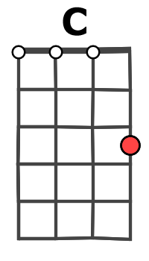
Am… Bb…
You…. Soft and only
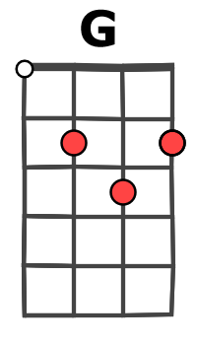
Am… Bb…
You…. Lost and lonely
Am… Bb…
You..… Strange as angels
F F
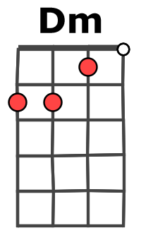
Dancing in the deepest oceans
F G
Twisting in the water
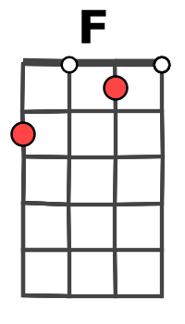
(C)
You're just like a dream

Interlude - C G Dm F x4

C G
Daylight licked me into shape
Dm F
I must have been asleep for days
C G
And moving lips to breathe her name
Dm F
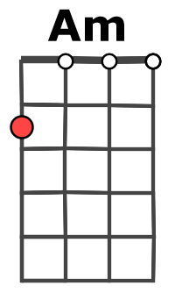
I opened up my eyes
C G
And found myself alone alone
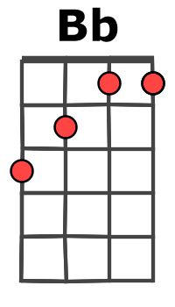
Dm F
Alone above a raging sea
C G
That stole the only girl I loved
Dm F
And drowned her deep inside of me
refrain
Am… Bb…
You…. Soft and only

Am… Bb…
You….Lost and lonely
Am… Bb… F…
You…Just like heaven

