
Wake me up when September ends Green day
Tonalité originale en G 2005 Bpm : 105

F F F F
F Am Dm C
Summer has come and passed The innocent can never last
Bb Bbm F F
Wake me up when September ends
F Am Dm C
Like my fathers' come to pass Seven years has gone so fast
Rythme 1 :
--------X------X--------
-----X-------X----------
--X-------X-------------
-------------------------

Bb Bbm F F
Wake me up when September ends

Dm Am Bb F
Here comes the rain again Falling from the stars
Rythme 2 (doux) :
B B B B B B B B
+ rythme 1
Dm Am Bb C
Drenched in my pain again Becoming who we are
F Am Dm C
As my memory rests But never forgets what I lost
Bb Bbm F F
Rythme 3 (fort) :
B B B B B B B B
Wake me up when September ends

F F F F
F Am Dm C
Summer has come and passed The innocent can never last
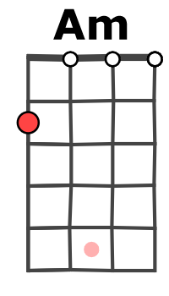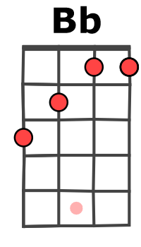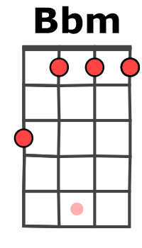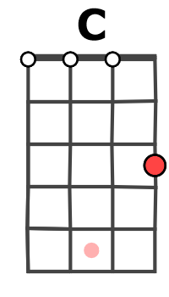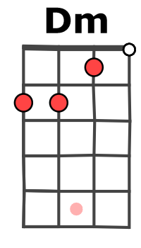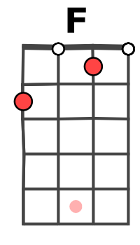
Bb Bbm F F
Wake me up when September ends
F Am Dm C
Ring out the bells again Like we did when spring began
Bb Bbm F F / Am
Wake me up when September ends

Dm Am Bb F
Here comes the rain again Falling from the stars
Dm Am Bb C
Drenched in my pain again Becoming who we are
F Am Dm C
As my memory rests But never forgets what I lost
Bb Bbm F F / Am
Wake me up when September ends
Instru :
Dm Am Bb F Dm Am Bb [C C ] x2
E/ ------5----5--5-----5-----5--5-----6-----6--6-8-8-8-8-8-8-8-8------5----5--5-----5-----5--5-----6-----6—6-[-8-8-8-8-8-8-8-8-8-8-8-8-8-8-8-8-]
C/ -5-5--5-5--5--4-4--4-4--4---5-5--5-5--5---5-5-5-5-4-4-4-4-5-5--5-5--5--4-4--4-4--4---5-5--5-5--5----[-5-5-5-5-5-5-5-5-4-4-4-4-4-4-4-4-]

F F F F
F Am Dm C
Summer has come and passed The innocent can never last
Bb Bbm F F
Wake me up when September ends
F Am Dm C
Like my fathers' come to pass Twenty years has gone so fast
Bb Bbm F F
G / V2
Wake me up when September ends x3

