
Where is my mind (Pixies, 1988) 162 BPM en G
G / Em
1 & 2 & 3 & 4 & 5 & 6 & 7 & 8 &
b b B b h b b B b h

B / C
1 & 2 & 3 & 4 & 5 & 6 & 7 & 8 &
b b B b h b b h B h b h

NC ( G / Em B / C ) x 4 (Les 2 derniers avec riff)
Ooh, stop Ooh

G / Em B / C
With your feet on the air and your head on the ground
G / Em B / C
Try this trick and spin it, yeah
G / Em B / C
Your head will collapse but there's nothing in it and you'll ask yourself
R
E
F
R
A
I
N
Couplet 1

G / Em B / C G / Em B / C
Where is my mind ? Where is my mind ? Where is my mind ?
G / Em B / C G / B C / Cm Em$ Dh
Way out in the wa-ter, see it swimming
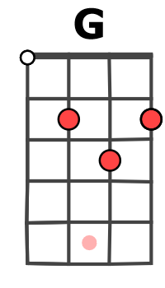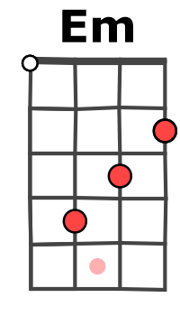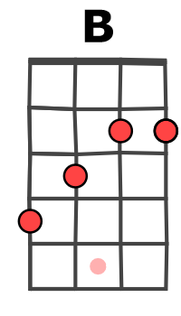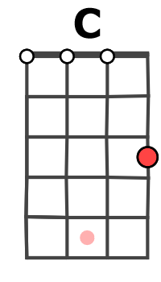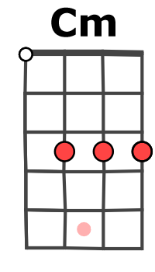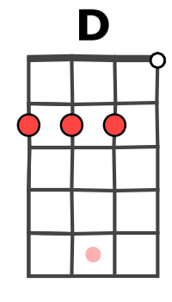

G / Em B / C
I was swimming in the Caribbean
G / Em B / C
Animals were hiding behind the rock
G / Em B / C
Except the little fish, bump into me, swear he's tryin' a talk to me, say wait wait

Couplet 1
REFRAIN Bh B h Bh

REFRAIN G / Em B / C
Ooh G / Em B / C
With your feet on the air and your head on the ground
G / Em B / C
Try this trick and spin it, yeah

( G / Em B / C ) X 3 G / Em Bh B$
Ooh Ooh
G / Em B / C
A..…….2…….2….…2….…2…….2….…2………………………..
E.....3……..3…….3…….3……2……..2…….3…...3..2..3..3..3..3
C...(2)………...…(4)…………(3)…………...(4)…………………..
G...(1)…………...(0)…………(4)…………...(5)…………………..
Riff sur l’ensemble du morceau sauf refrains
M-A V0

