
I will survive
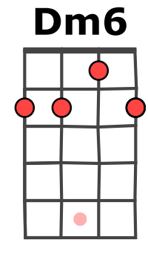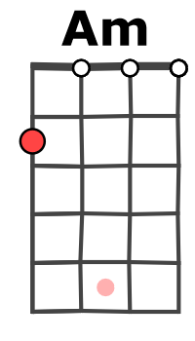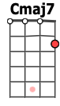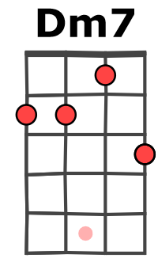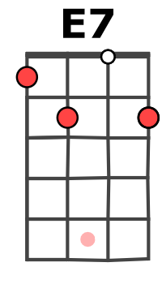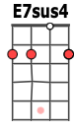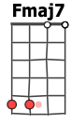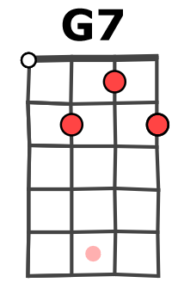
(Gloria Gaynor, 1978)
216 (234) BPM tona originale

Am… Dm7… G7… Cmaj7…
At first I was afraid, I was petrified, kept thinking I could never live without you by my side.
Fmaj7… Dm6…
But then I spent so many nights, thinking how you did me wrong,
E7sus4… E7…
And I grew strong and I learned how to get along.
1 & 2 & 3 & 4 & 5 & 6 & 7 & 8 &
B B h B

Am Dm7
But so you're back, from outer space,
G7 Cmaj7
I just walked in, to find you here, with that sad look upon your face.
Fmaj7 Dm6
I should have changed that stupid lock, I should have made you leave your key,
E7sus4 E7
If I had known for just one second, you'd be back to bother me.
PRÉ REFRAIN
1 & 2 & 3 & 4 & 5 & 6 & 7 & 8 &
B B B B h h h b h b h

1 & 2 & 3 & 4 & 5 & 6 & 7 & 8 &
B B h B b h b h

Am Dm7
Am Dm7
Oh no, not I ; I will survive,
G7
Oh, as long as I know how to love,
Cmaj7
I know I'll stay alive.
Fmaj7
I've got all my life to live,
Dm6
And I've got all my love to give,
E7sus4 E7
And I'll survive, I will survive, hey hey

Go on now, go, walk out the door
G7
Just turn around now,
Cmaj7
'Cos you're not welcome any more.
REFRAIN
Fmaj7
Weren't you the one who tried
Dm6
To hurt (2break) me with goodbye ?
E7sus4
Did you think I'd crumble ;
E7
did you think I'd lay down and die ?
Strum refrain

Am Dm7 G7 Cmaj7 Fmaj7 Dm6 E7sus4 E7

1 & 2 & 3 & 4 & 5 & 6 & 7 & 8 &
B B h h h b h b h

Am Dm7
3. It took all the strength I had not to fall apart.
4. And you see me ; somebody new,
G7 Cmaj7
P
R
É R
E
F

R
E
F
R
A
I
N
P
R
É R
E
F
R
E
F
R
A
I
N
3. Kept trying hard to mend the pieces of my broken heart.
4. I'm not that chained up little person, still in love with you.
Fmaj7 Dm6
3. And I spent oh, so many nights, just feeling sorry for myself,
4. And so you felt like dropping in and just expect me to be free,
E7sus4 E7
3. I used to cry, but now I hold my head up high.
Strum idem refrain
4. Well, now I'm saving all my loving, for some-one who's loving me
La la la…
Strum refrain
Am Dm7 G7 Cmaj7 Fmaj7 Dm6 E7sus4 E7h Pause…

B . . . B . . . B . . . B

(Am Dm7 G7 Cmaj7 Fmaj7 Dm6 E7sus4 E7) x 3

Ami Crescendo !!! de 65 à 400BPM
M-A V1

