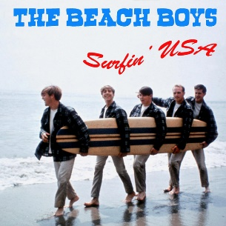
Surfin’ USA The Beach Boys (Chuck Berry) 1963 BPM : 158
Tonalité originale : A#
Intro : A /------------3--3--3------3------3-----3---
E /------------3--3--3------3------3-----3---
C /-0--4--5--4--4--4--5--4--0--4--5--4---

G G↓ C C↓
If everybody had an ocean (Uuuu) Across the U.S.A. (Uuuu)
G G↓ C C↓
Then everybody'd be surfin' (Uuuu) Like Californi-a (Uuuu)
F F↓ C C↓
You'd seem 'em wearing their baggies (Uuuu) Huarachi sandals too (Uuuu)
G F↓ C C
A bushy bushy blonde hairdo (Uuuu) Surfin' U.S.A. (Uuuu)
G G C C
You'd catch 'em surfin' at Del Mar (Inside Outside USA) Ventura County line (Ins. Out. USA)
G G C C
Santa Cruz and Trestle (Inside Outside USA) Australia's Narrabeen (Inside Outside USA)
F F C C
All over Manhattan (Inside Outside USA) And down Doheny Way (Inside Outside USA)
G F↓ C C↓
Everybody's gone surfin' Surfin' U.S.A.
Partie 1

G G↓ C C↓
We'll all be planning out a route (Uuuu) We're gonna take real soon (Uuuu)
G G↓ C C↓
We're waxin’ down our surfboards (Uuuu) We can't wait for June (Uuuu)
F F↓ C C↓
We'll all be gone for the summer (Uuuu) We're on surfari to stay (Uuuu)
G F↓ C C
Tell the teacher we're surfin' (Uuuu) Surfin' U.S.A. (Uuuu)
G G C C
Haggerties and Swamies (Inside Outside USA) Pacific Palisades (Inside Outside USA)
G G C C
San Anofree and Sunset (Inside Outside USA) Redondo Beach L.A. (Inside Outside USA)
F F C C
All over La Jolla (Inside Outside USA) At Waimia Bay (Inside Outside USA)
G F↓ C C↓
Partie 2
Everybody's gone surfin' Surfin' U.S.A.
Instru : G G C C G G C C F F C C
Rythme :
G = G G Em G G G Em G
↓ ↓ ↑ ↑ ↓ ↑
C = C C Am/C C C C Am/C C
↓ ↓ ↑ ↑ ↓ ↑
F = F F Dm F F F Dm F
↓ ↓ ↑ ↑ ↓ ↑

G F↓ C C↓
Everybody's gone surfin' Surfin' U.S.A.

Partie 2

G F↓ C C↓
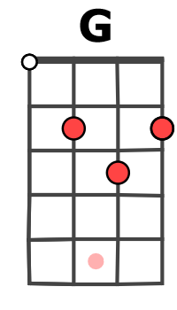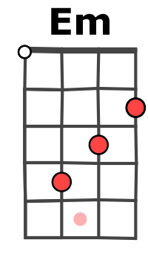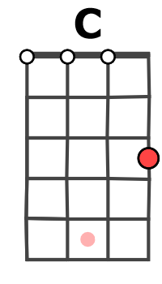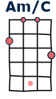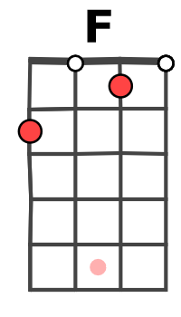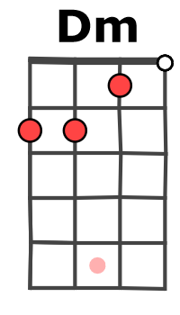

Everybody's gone surfin' Surfin' U.S.A. (x2)
G / V2

