
Don’t look back in anger Oasis, 1995 164 BPM
Tonalité originale : C

D G D G

D / A Bm / F#m
Slip inside the eye of your mind….. don't you know you might find
G / A D / Bm // A
A better place to play
D / A Bm / F#m
Rythme :
B B B BhB B B Bh
You said that you'd never been……. but all the things that you've seen
G / A D / Bm // A
Slowly fade away

G / Gm6 D G / Gm6 D
So I start a revolution from my bed 'cause you said the brains I had went to my head
I’am gonna start a revolution from my bed 'cause you said the brains I had went to my head
G / Gm6 D
Step outside, summertime's in bloom
A Bbdim
Stand up beside the fireplace…… take that look from off your face
Bm / A G A A
(Caus’) You ain't ever gon-na burn my heart out

D / A Bm / F#m G / A6 D / Bm // A
And so…... Sally can wait….. she knows it's too late as we're wal-king on by
D / A Bm / F#m G / A6 D / A
Her soul…… slides away………… but don't look back in anger I heard you say
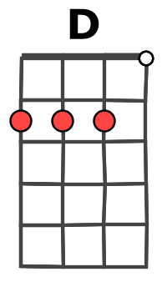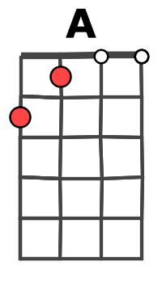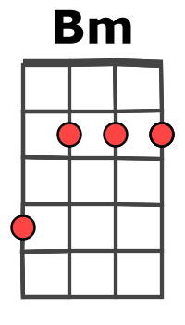
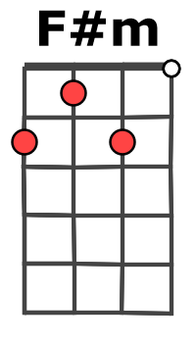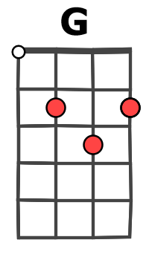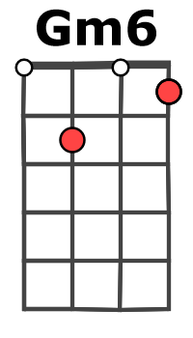
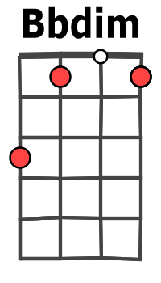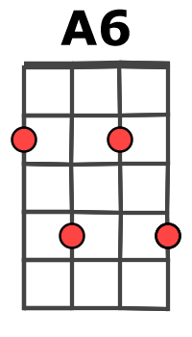

Bm / F#m G / A D / Bm // A

D / A Bm / F#m
Take me to the place where you go…… where nobody knows
G / A D / Bm // A
If it's night or day
D / A Bm / F#m
But please don't put your life in the hands of a rock and roll band
G / A D / Bm // A
Who'll throw it all away

PREREFRAIN (en bleu)

D / A Bm / F#m G / A6 D / Bm // A
And so…... Sally can wait….. she knows it's too late as we're wal-king on by
D / A Bm / F#m G / A6 D / Bm // A
My (her) soul…… slides away……..… but don't look back in anger I heard you say
G / Gm6 D G / Gm6 D G / Gm6 D A Bbdim Bm / A G A A

REFRAIN (her soul)

D / A Bm / F#m G / A6 D / Bm // A
So…... Sally can wait….. she knows it's too late as we're wal-king on by
D / A Bm G
My soul…… slides away………… but don't look back in anger
Gm6 D / A Bm / F#m G / Gm6 C…
Don’t look back in anger… I heard you say……………………………..…….. it’s not too late
M A / V1

