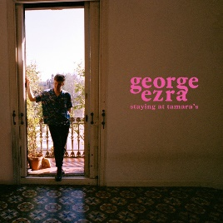
SHOTGUN George Ezra 2018 Tonalité originale Bpm : 116
Rythme prérefrain : b b b b x2 Rythme refrain : B B B B x2

F… Bb… Dm… C…
Homegrown alligator see you later gotta hit the road gotta hit the road
F… Bb…
Something changed in the atmosphere architecture unfamiliar
Dm… C…
I could get used to this
Prérefrain

F Bb Dm C
Time flies by in the yellow and green stick around and you'll see what I mean
F Bb Dm C
There's a mountaintop that I'm dreaming of if you need me you know where I'll be
Refrain
F Bb Dm C
I'll be riding shotgun underneath the hot sun feeling like a someone
F Bb Dm C
I'll be riding shotgun underneath the hot sun feeling like a someone
F… Bb… Dm… C…
We're south of the Equator navigator gotta hit the road gotta hit the road
F… Bb…
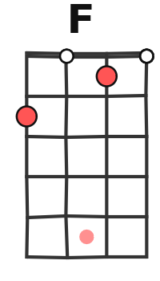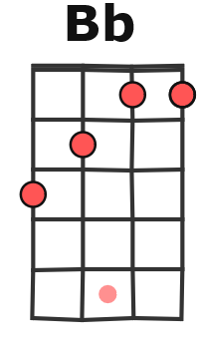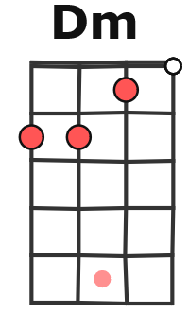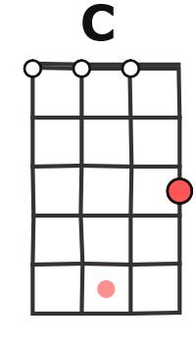
Deep sea diving 'round the clock bikini bottoms lager tops
Dm… C…
I could get used to this

Prérefrain Refrain

F Bb Dm C

We got two in the front two in the back sailing along and we don't look back
F Bb Dm C

(F) (Bb) (Dm) (C)
Time flies by in the yellow and green stick around and you'll see what I mean
(F) (Bb) (Dm) (C)
There's a mountaintop that I'm dreaming of if you need me you know where I'll be
F Bb Dm C
I'll be riding shotgun underneath the hot sun feeling like a someone someone someone
F Bb Dm C
I'll be riding shotgun underneath the hot sun feeling like a someone
F Bb Dm C
I'll be riding shotgun underneath the hot sun feeling like a someone someone someone
F Bb
I'll be riding shotgun underneath the hot sun
Dm C F Bb Dm C F…
Feeling like a someone a someone a someone a some
G / V1

