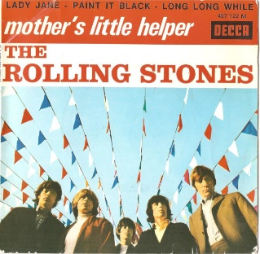
Mother's Little Helper The Rolling Stones 1966
Bpm : 101 Tonalité originale

(Am) C… D… Em… Em Em Em¤ Em¤ Em¤ Em¤
What a drag it is getting old

Em Em Em Em Em
Kids are different today I hear e-very mother say
Em Em F
Mother needs something today to calm her down
D G G C Am
Rythme : B Bh hBh
And though she's not really ill there's a little yellow pill
Am↓ (Am) D7↓ (D7)
She goes running for the shel-ter of her mother's little hel-per
Em Em Em Em¤ Em¤ Em¤ Em¤
And it helps her on her way gets her throu-gh her busy day
Em¤ Em¤ Em¤ Em¤
1&2&3&4&1&2&3&4&
E : 2-3--5 3-2--3
Em Em Em Em Em
Things are different today I hear e-very mother say
Em Em F
Cooking fresh food for her husband's just a drag
D G G C Am
So she buys an instant cake and she burns a frozen steak
Am↓ (Am) D7↓ (D7)
And goes running for the shel-ter of her mother's little hel-per
Em Em Em Em¤ Em¤ Em¤ Em¤
And two help her on her way get her throu-gh her busy day

C C D D G G
Doctor, please some more of these Outside the door
C C / Am C D Em¤ Em¤
She took four more What a drag it is getting old
Refrain

Em Em Em Em Em
Men just aren't the same today I hear e-very mother say
Em Em F
They just don't appreciate that you get tired
D G G C Am
They're so hard to satisfy you can tranquilize your mind
Am↓ (Am) D7↓ (D7)
So go running for the shel-ter of a mother's little hel-per
Em Em Em Em¤ Em¤ Em¤ Em¤
And four help you through the night help to minimize your plight

Refrain
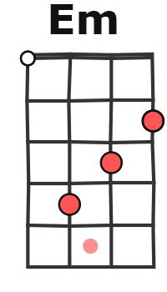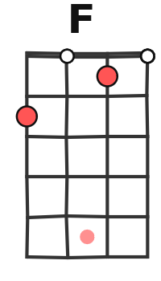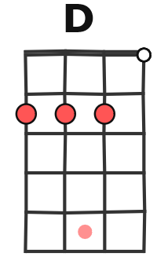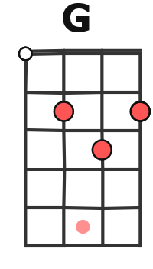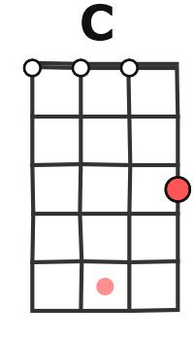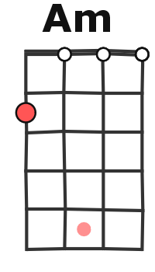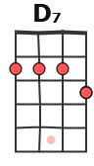

Em Em Em Em Em
Life's just much too hard today I hear e-very mother say
Em Em F
The pursuit of happiness just seems a bore
D G G C Am
And if you take more of those you will get an overdose
Am↓ (Am) D7↓ (D7)
No more running for the shel-ter of a mother's little hel-per
Em Em Em Em¤ Em¤ Em¤ Em¤
They just helped you on your way through your busy dying day
G / V1
G G
Hey

