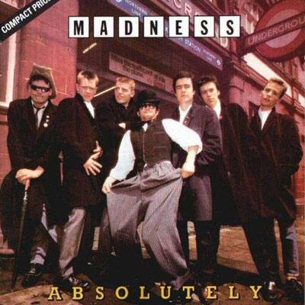
Baggy trousers Madness 1980 Ton. orig. Bpm : 144

Intro : B↓ / Bb↓ // Ab↓ F B↓ / Bb↓ // Ab↓
F Ab
Naughty boys in nasty schools head-masters breaking all the rules
Bb B↓ / Bb↓ // Ab↓
Having fun and playing fools smashing up the woodwork tools
F Ab
All the teachers in the pub passing 'round the ready-rub
Rythme couplet : Xh h h h
Rythme refrain : BhBxBhBx
Bb B↓ / Bb↓ // Ab↓
Trying not to think of when the lunch-time bell will ring a-gain
Couplet + instru:
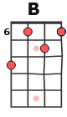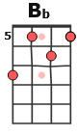
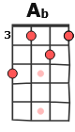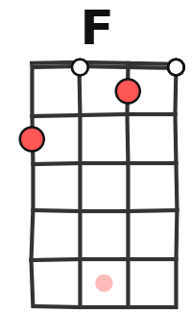
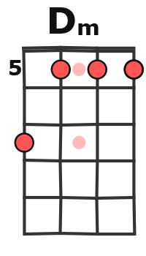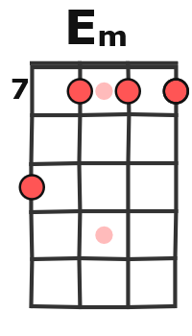
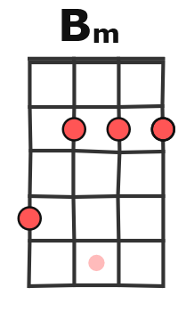

Bb / Bbm F / Fm
Refrain 1
Oh what fun we had but did it really turn out bad ?
Bb / Bbm C / [B] C
All I learnt at school was how to bend not break the rules
Bb / Bbm F / Fm
Oh what fun we had but at the time it seemed so bad.
Bb / Bbm C / B↓ Bb↓ // Ab↓
Trying different ways to make a difference to... The head…

F Ab
Master's had enough today all the kids have gone away
Bb B↓ / Bb↓ // Ab↓
Gone to fight with next-door's school every term that is the rule
F Ab
Sits alone and bends his cane same old backsides again
Bb B↓ / Bb↓ // Ab↓
All the small ones tell tall tales walking home and squashing snails

Bb / Bbm F / Fm
Refrain 2
Refrain :
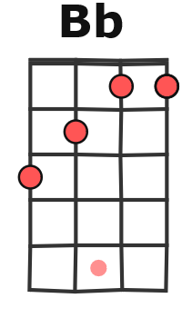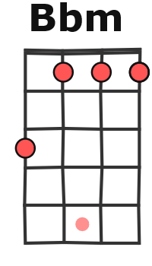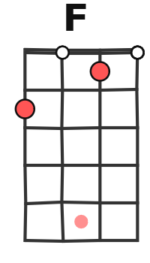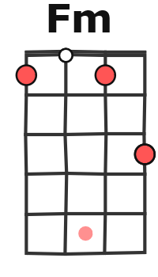
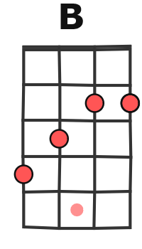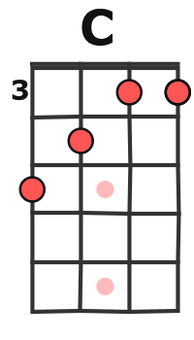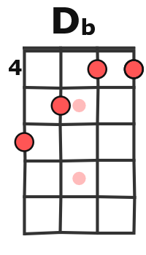

Oh what fun we had but did it really turn out bad ?
Bb / Bbm C / [B] C
All I learnt at school was how to bend not break the rules
Bb / Bbm F / Fm
Oh what fun we had but at the time it seemed so bad
Bb / Bbm C↓ / C↓// Db↓ (Dm)
Trying different ways to make a difference to the days

Instru : Dm / Em Dm / Bm x3 Dm / Em Dm / B↓Bb↓A↓ Ab↓

F Ab
Lots of girls and lots of boys lots of smells and lots of noise
Bb B↓ / Bb↓ // Ab↓
Playing football in the park kicking pushbikes after dark
F Ab
Baggy trousers dirty shirt pulling hair and eating dirt
Bb B↓ / Bb↓ // Ab↓
Teacher comes to break it up back of the head with a plastic cup

Refrain 2 Dm / Em Dm / Bm x3 Dm / Em Dm / B↓Bb↓A↓ Ab↓

F Ab Bb B↓Bb↓A↓ Ab↓
G / V1

Baggy trousers baggy trousers baggy trousers. X3

