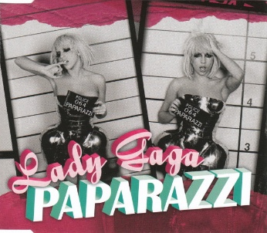
Paparazzi Lady Gaga 2009
115 bpm. Tonalité G
Strum Calypso : B Bh hBh

INTRO : Bm Bm

Bm Bm
We are the crowd, We're c-coming out, Got my flash on, it's true, Need that picture of you
G Bm
It's so magical, We'd be so fantastical
Bm Bm
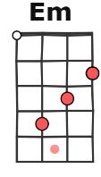
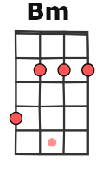
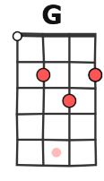
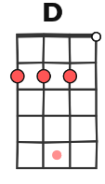
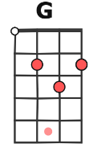
Leather and jeans, Garage glamorous, Not sure what it means, But this photo of us,
G Em
It don't have a price, Ready for those flashing lights, 'Cause you know that baby I
Refrain
C / D Em / G
I'm your biggest fan, I'll follow you until you love me, Papa-paparazzi
C / D Em / G
Baby, there's no other superstar, You know that I'll be, Your papa-paparazzi
C / D Em / C
Promise I'll be kind, But I won't stop until that boy is mine
C / D Em / G
Baby, you'll be famous, Chase you down until you love me, Papa-paparazzi

Bm Bm

Bm Bm
I'll be your girl backstage at your show, Velvet ropes and guitars, Yeah 'cause you're my rock star
G Bm
in between the sets, Eyeliner and cigarettes
Bm Bm
Shadow is burnt, Yellow dance and we turn, My lashes are dry, Purple teardrops I cry,
G Em
It don't have a price, Loving you is cherry pie, 'Cause you know that baby I
Refrain

Bm
Real good, We dance in the studio
Bm
Snap snap to that shit on the radio
G Em
Don't stop for anyone, We're plastic but we still have fun
Refrain
C… D… Em… G…
I'm your biggest fan, I'll follow you until you love me, Papa-paparazzi
C… D… Em… G…
Baby, there's no other superstar, You know that I'll be, Your papa-paparazzi

C / D Em / C
Promise I'll be kind, But I won't stop until that boy is mine
C / D Em / G
Baby, you'll be famous, Chase you down until you love me, Papa-paparazzi
A
G…

