I Love To Singa - Cab Calloway, Al Jolson (1936) BPM 126
Strum swing B B B B

C7M Am7 Fm6 G7 C C7
I love to sing-a About the moon-a and the June-a and the spring-a,
F Fm C Am Dm G7
I love to sing-a, About a sky of blue-a, or a tea for two-a,
C Am Dm Bdim7
Anything-a with a swing-a to an "I love you-a, "
C Am Dm G7 C Gdim7 G7 %
I love to, I love to sing!
C7M Am7 Fm6 G7 C C7
Give me a song-a About a son-a gun that went and done her wrong-a.
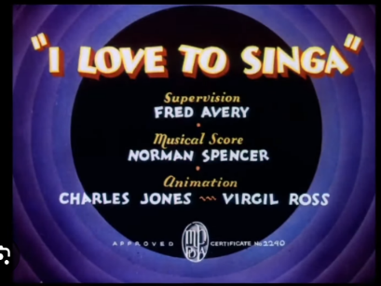
F Fm C Am Dm G7
But keep it clean-a, With a cottage small-a by a waterfall-a,
C Am Dm Bdim7
Any sob-a that will throb-a to a bluebird's call-a,
C Am Dm G7 C Gdim7 G7 %
I love, I love to sing!
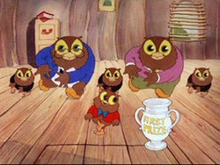
E7 (shuffle) Am6
BRIDGE
I was born a singin' fool-a, knock twice Lah-de-dah!
Am6
Ol' Major Bowes is gonna spot me,
D7 D7
Got through Yale with boula-boula, Lah-de-dah!
Dm Gdim7 G7
Old microphone's got me!
C7M Am7 Fm6 G7 C C7
I love to sing-a, I love to wake up with the south-a in my mouth-a,
F Fm C Am Dm Bdim7
And wave a flag-a, With a cheer for Uncle Sammy and another for my mammy,
Dm % G7 % C % % %
I love to sing!
Variante d’accords pour le couplet :
C - Cmaj7 - Fm6 - G7 - C - C7
F - Fm - C - Am - Dm - G7
C - Am - Dm - Fdim
C - Am - Dm - G7
C - Edim - G7 %
The swingin'est,
Hot singin'est,
Bell-ringin'est,
Song singin'est
High tootin'est,
Sky tootin'est,
I love to sing!
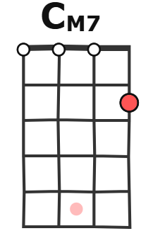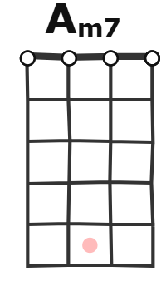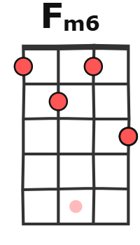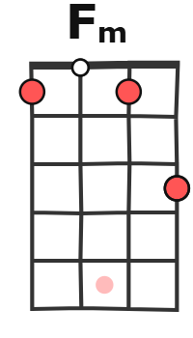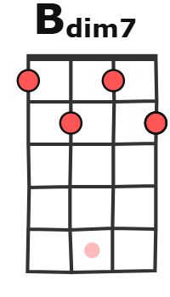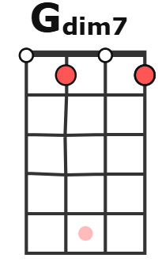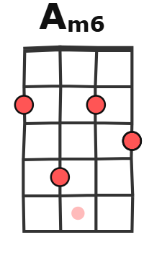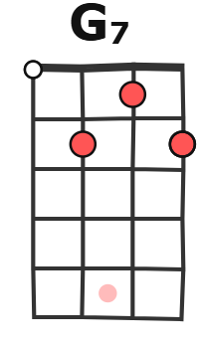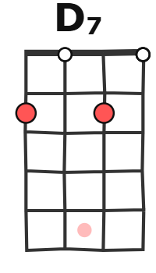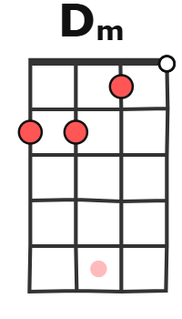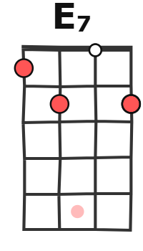
As with several early Warners cartoons, it is in a sense a music video designed to push a song from the Warners library. The song in question, "I Love to Singa", was first written by Harold Arlen and E.Y. Harburg for the 1936 Warner Bros. feature-length film The Singing Kid.
It is performed three times in the film: first by Al Jolson and Cab Calloway, then by the Yacht Club Boys and Jolson, and finally again by Calloway and Jolson. During this period, it was customary for Warners to have their animation production partner, Leon Schlesinger Productions, make Merrie Melodies cartoons based upon songs from their features.

