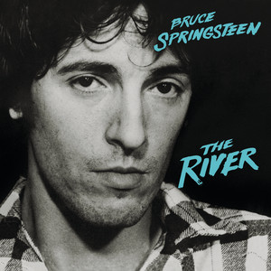
Hungry heart Bruce Springsteen 1980 BPM : 110
Tona originale : C#
Intro : A F#m Bm E7 x2

A F#m
Got a wife and kids in Baltimore Jack
Bm E7
I went out for a ride and I never went back
A F#m
Rythme : B Bh hBh
Like a river that don't know where it's flowing
Bm E7
I took a wrong turn and I just kept going
Refrain 1
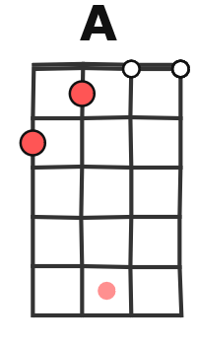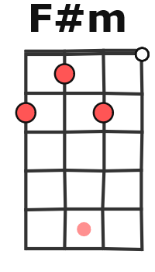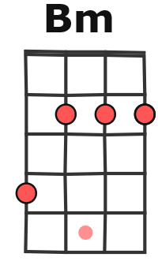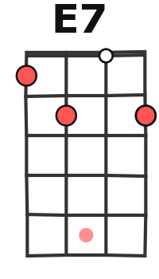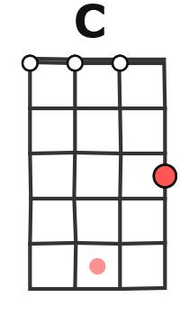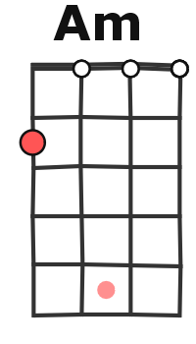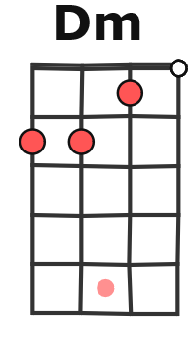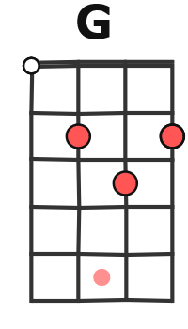
A F#m Bm E7
Everybody's got a hungry heart Everybody's got a hungry heart
A F#m
Lay down your money and you play your part
Bm E7 (A)
Everybody's got a h-h-hungry heart

Instru 1 : A F#m Bm E7
♥ à partir du 2ème couplet sauf instru 2
Oh oh

A F#m Bm E7
I met her in a Kingstown bar We fell in love I knew it had to end
A F#m
We took what we had and we ripped it apart
Bm E7
Now here I am down in Kingstown again
Refrain 2
A F#m Bm E7
Everybody's got a hungry heart Everybody's got a hungry heart
A F#m
Lay down your money and you play your part
Bm E7 (C)
Everybody's got a h-h-hungry heart

Instru 2 : C Am Dm G C Am Dm E7
La-la-la-la-la-la oh yeah La-la-la-la-la-la
A F#m Bm E7
Everybody needs a place to rest Everybody wants to have a home
A F#m Bm E7
Don't make no difference what no-body says Ain't nobody like to be alone
Sur refrains et Instru 1
A F#m Bm E7
A/ 2-4-4-4-4-4-4-4-2-4-4-4-4-4-4-4-4-5-5-5-5-5-5-5-4-5-5-5-5-5-5-5…
E/ 4-5-5-5-5-5-5-5-4-5-5-5-5-5-5-5-5-7-7-7-7-7-7-7-5-7-7-7-7-7-7-7…

Refrain 1 x2
G / V3

