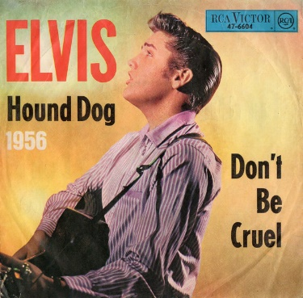
Hound dog Elvis Presley 1956 (Big Mama Thornton 1952)
Bpm : 174 Tonalité originale : C
Rythme B Xh hXX

(Do) A A A A
You ain′t nothin' but a hound dog Cryin′ all the time
D D A A
You ain't nothin' but a hound dog Cryin′ all the time
E ↓
Well, you ain′t never caught a rabbit
Refrain
D ↓ A
And you ain't no friend of mine

A A A A
When they said you was high classed Well, that was just a lie
D D A A
Yeah, they said you was high classed Well, that was just a lie
E ↓
Yeah, you ain′t never caught a rabbit
D ↓ A
And you ain't no friend of mine

Refrain

Solo : A A A A D D A A E D A A ↓

A↓ A↓ A↓ A↓
When they said you was high classed Well, that was just a lie
D↓ D↓ A↓ A↓
Yeah, they said you was high classed Well, that was just a lie
E ↓
Yeah, you ain′t never caught a rabbit
D ↓ A↓ A↓
And you ain't no friend of mine

Refrain C - A↓

G / V1
