These boots are made for walkin’ Nancy Sinatra 1966
Bpm : 83 Tonalité originale : E
A / 0-0-0-0-0-0-0-0-0-0-0-0-0-0-0-0
E / ------------------------------------------
C / 9-9-8-8-7-7-6-6-5-5-4-4-3-3-2-0

Rythme couplet : B BhB Bh
Rythme refrain : B Bh hBh

Intro / Descente :

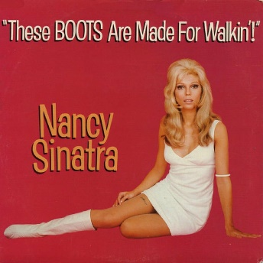
A A A A A A A A
You keep sayin' you've got somethin' for me
A A A A
Somethin' you call love but confess
D D D D
You've been a'messin' where you shouldn't 've been a'messin'
A A A A
And now someone else is getting all your best
Refrain
C A
These boots are made for walkin'
C A
And that's just what they'll do
C A↓ Descente
One of these days these boots are gonna walk all over you
A A A A A A A A
You keep lyin' when you oughta be truthin'
A A A A
And you keep losing when you oughta not bet
D D D D
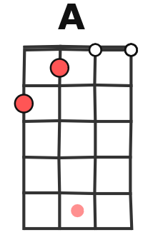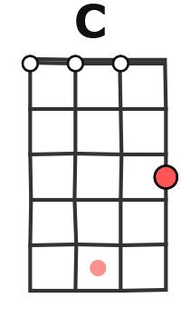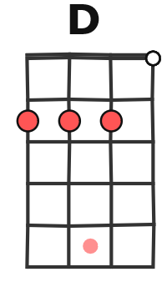
You keep samin' when you oughta be a'changin'
A A A A
Now what's right is right but you ain't been right yet

Refrain
A A A A A A A A
You keep playin' where you shouldn't be playin'
A A A A
And you keep thinkin' that you'll never get burnt ha
D D D D
I just found me a brand new box of matches yeah
A A A A
And what he knows you ain't had time to learn
Refrain

A A A A A A A A ad lib…
Are you ready, boots? Start walkin'
E / 5-----------3-4-5-------------3-4-5---
C / -----4----4-----------4----4-----------

G / V1

